Los Altos Rotary Program Rating

The purpose of the program speaker survey is to rate the speakers so that future program committees can make better decisions on selecting speakers and topics that are of most interest to members.

The Program Committee has been rating speakers since July 2010. The Committee decided to provide the survey questionnaire to any member who wishes to participate.

If you decide you want to evaulate our speakers, you will receive an e-mail, as shown below:
If you have trouble viewing or submitting this form, you can fill it out online:
https://spreadsheets.google.com/viewform?formkey=dDdsd212c0RMdVRhQmo3WUY4UnN5Q0E6MA
Los Altos Rotary Program Rating
[Name of current speaker]

By clicking on the above URL, you will open a questionnaire as shown below:

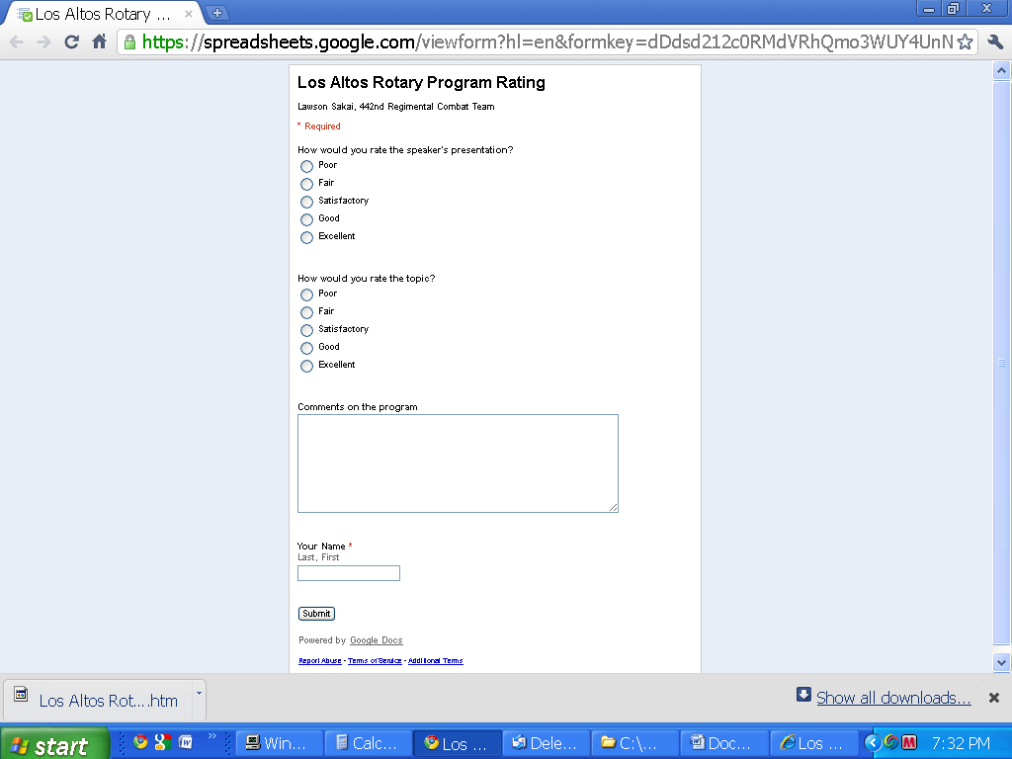

Filling it in and clicking “Submit” will send it to a Google server. The software will display all responses in a spread sheet. The responses can be averaged to come up with a rating between 0 and 10 for both the speaker and the topic questions. (Excellent =10; Good = 7.5; Satisfactory = 5.0; Fair = 2.5; Poor = 0).

You will be e-mailed a complete list of all responses and the calculated average ratings for the speaker’s presentation and the topic. The survey results will look like this:

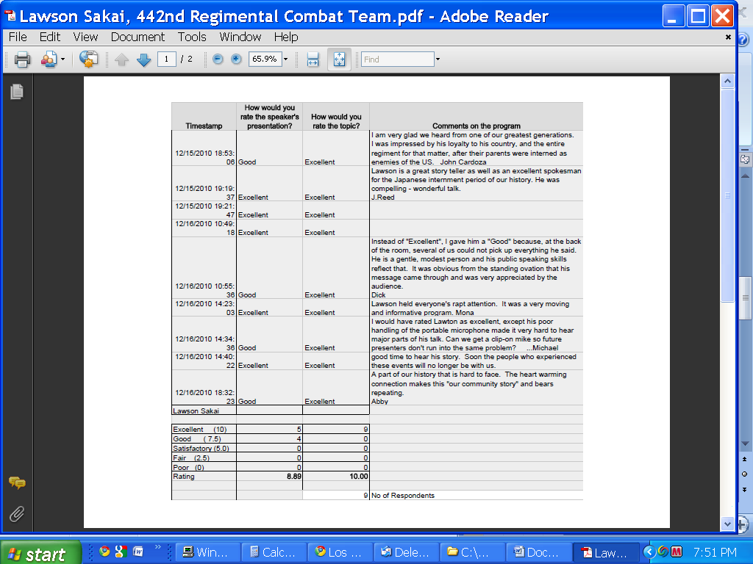

If you wish to be included in the e-mail list for the speaker survey, or if you have any questions, please contact:

John Cardoza
john134@sbcglobal.net
(650) 948-8172

