Dear Friends of Proyecto Itzaes
I have been here in Yucatan for almost two weeks now and I have much to report from our six villages. I wish somehow that I could email more than just words and photos so that you too could feel the sense of community and the excitement for learning as families arrive for book exchange; with kids clustered in corners reading, playing with puzzles, drawing, putting on puppet shows and working on computers. Most of our participating families live in extreme poverty (less than $1.00/day per capita) and the Proyecto Itzaes books, programs and resources provide essential services. With your continued help Proyecto Itzaes (PI) programs are making a meaningful difference in the lives of the families we serve. http://www.proyectoitzaesusa.org

Our literacy and early reading programs got a tremendous boost in February when the Bring Me A Book Foundation (BMAB) delivered hundreds of beautiful hardbound Spanish language books to the villages of Ixil, Mococha, and Dzemul. The green BMAB book bags and the wooden display shelves were produced locally, not only creating jobs for our families and reinforcing the community spirit of the program, but also reducing our shipping costs and carbon footprint. The carefully chosen titles represent the best of Spanish language books from all over the world and provide much needed books for our primary and middle school readers.
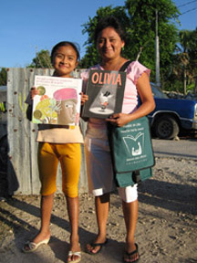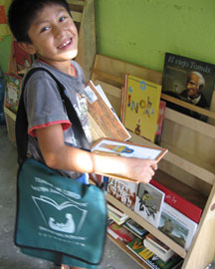
Our health and nutrition project, funded by Rotary International, Palo Alto Rotary and Merida Club Rotario Nuevas Generaciones (NG) in 2006 provided computers and other technology to all six villages to provide education for the prevention of Type ll diabetes. Students continue to interview elders in their villages about local foods and diet before the arrival of fast food. The students compare this to their own diets and are researching how foods and obesity are related to diabetes. This project has produced valuable historical information (now archived digitally) about Maya village life, agricultural methods, health and land use. Below is a photo of don Nando Pech who was interviewed by his grandchildren.
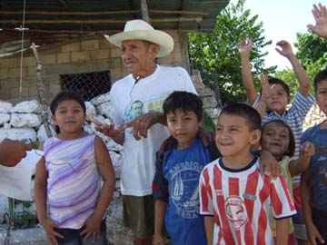
During a three day Rotary work project in February, planters were constructed in Ixil and Mococha where Proyecto Itzaes students are now learning through experience about healthy food, native plants, and ecology. This same weekend volunteers from Los Altos, Palo Alto, Toronto and Merida painted the casitas inside and out, repaired electrical circuits and donated books, shelves and toys.
Photos on our webpage: http://www.proyectoitzaesusa.org click on our Flickr photots
Our Science in the Villages program provides environmental education and local biodiversity. This summer's programs (very much kid driven) include exploring native flora and fauna, growing native maiz, and a student based seed and specimen collection. Below is a photo of our summer volunteers ( middle and high school students) learning to use a USB microscope before teaching younger students in the summer program.
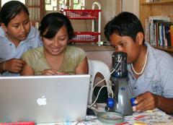

Your generous support of Proyecto Itzaes continues to make a big difference! I will send more updates and links to photos soon.

Mil gracias y dios bo'otik

Cindy

